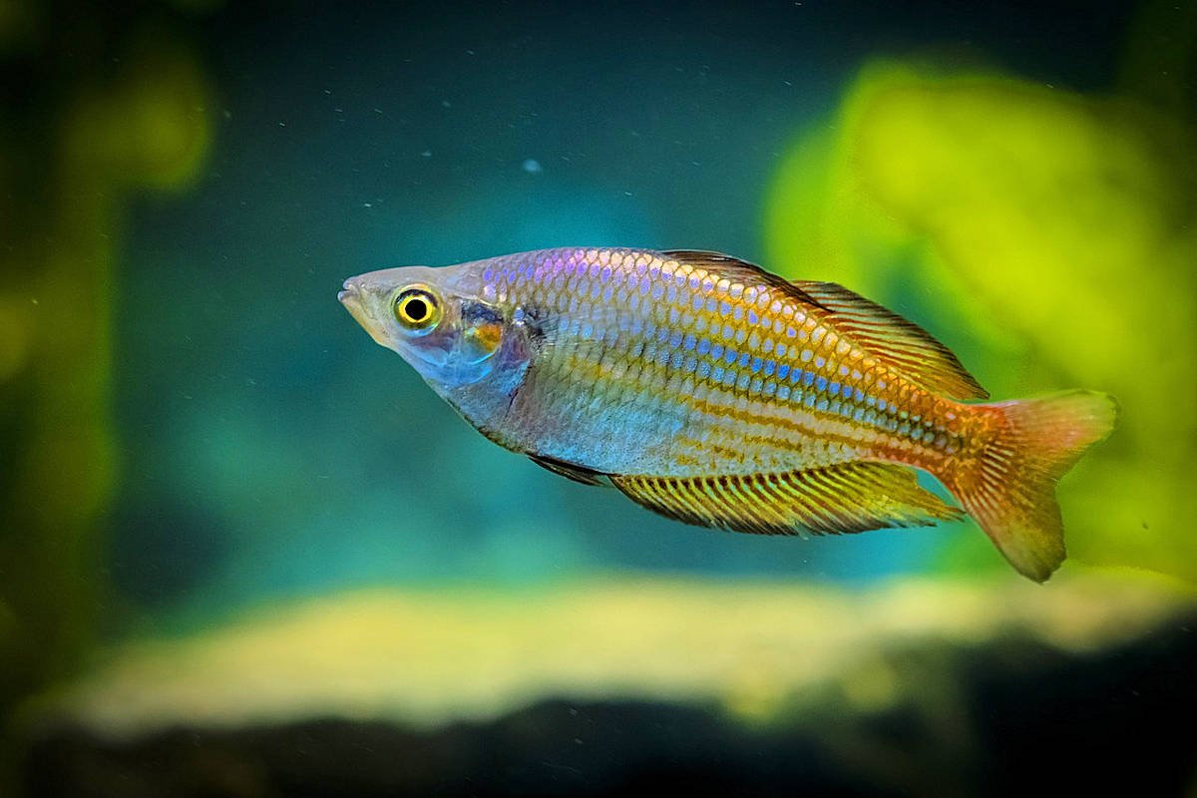

**Name:** Rainbow fish

**Habitat:** Lives in the ocean

**Abilities:** Can swim and live in captivity, can´t walk

**Diet:** Sea plants